7.9

Half year review, prospects and goals.

The key to outperforming the market is

1. delta in the correct direction
2. Trade around your position (jack Schwager)
3. Always let delta work out by themselves – don’t manually trade delta
4. Delta control so that net exposure is small
5. When vol goes up emphasize on short (high vol is never a good thing)

Goal

1. Keep emotional involvement low
2. Keep manual intervention to 0 going forward, even 1 lot trade needs to be programmatically
3. Stock trades accumulation will be done with tools, this ties into item #1.
4. Stock sell/buy will be done over a long period of time, to take advantage of long range swings, this is optionality
5. Keep trading size per day low.
6. No huge delta swings from day to day.
7. Net delta reflects views in a particular period.
8. Delta swings within -1 to 1 mm

Today synapsis:

1. Markets rebound in a retaliatory fashion
2. When markets rises like this, looks like 回光返照
3. Keep short and let position take care of itself until MA20 changes.
4. Huge moveups are never good. Usually bad stuff happens after.
5. Chinese market is suitable for long term shorting

First half year good and bad

Good

1. Moved to full automated trading
2. Delta is more controlled than Feb (7mm delta was at its most, with 300k daily pnl) delta was not adjusted j

今天盗窃了一个群.

主要是吴荣不得民心, 出于自私和私利突然解散群, 这个时候就留出了一个真空.

我迅速建了一个同名群, 让大家拉入, 大家还不适应没有这个群, 所谓的loss aversion.

所以大家都踊跃加入, 不明情况的人也被人拉人的方法拉进来.

我迅速把吴荣拉黑, 因为他必然会指责我重新建群. 而且他进了群以后也会被我踢掉, 所以是我不加他是肯定的. 所以说, 我利用吴荣4年心血建立的群, 轻松了窃取了过来. 他以后会逐渐的把人拉回来, 但是他就丧失了正当性. 谁愿意和一个吐露反涨的人接触呢?

这个群的管理方面实施无为而治, 一般不讲话, 就让大家在群里吹水. 看看能不能搞的很热络. Lilymoon找我要管理权限, 我是不会给的. 她跟吴荣好, 吴荣进来以后一定会把我踢掉. 她对吴荣的妥协态度, 重新拉他入群这一点挑战了我的权威, 肯定不能答应, 而且我也在伺机除之. 在群的初期发展阶段, 不出现. 太上, 不知有之. 这样是最好的. 不需要在群里说任何话, 没了吴荣, 还是要继续.

这次夺权的优缺点

优点包括迅速夺取领导权, 这个权力是很大的social proof. 用同样的名字是极大的撺掇了以前群积累的名气. 吴荣以后的群肯定会排除你也跟你结了仇. 因为毕竟删好友是不友善的, 不过他这么做,伤了群友的心, 也确实不合时宜. 不做掉他, 就不能掌握群里的大权.

79 Next

You need to hold on firmly to your rights and resources.

This way you are not subject to the control of other individuals or oppressive/incorrect sources of power. Be polite to people. Keep your thoughts to yourself, hold on tightly to your resources.

If you are using others’ resources, you will be subject to others’ control.

A lot of people have no clue about inflation, cash flow, land ownership etc.

There is limit to people’s achievement due to limits on education, exposure etc.

Before all, be polite. Make judgments silently and don’t voice your real thoughts.

Understand and exploit opportunities. Do things silently, not loudly.

Grow silently.

Don’t interact overly with idiots of lower intellectual caliber.

Don’t repeat yourself.

What happened in the conversation is clearly, A is trying to use the resources of B, but B’s intellectual capability is not able to comprehend the meaning of A’s actions. B’s knowledge is limited and does not understand things like inflation and has not had a good enough education to carry on a conversation without getting angry (lack of communication skills). A has been influenced by C so that A knows a bit about value preservation.

Money is made by optimistic people like Buffett, who believes that the economy always grows, and by Li Ka Shing, who buys property on lows each time, because he believes in HK’s future.

There are a lot of people with limited capabilities, people who don’t grow over time.

There is no point in carrying on a conversation with unworthy people.

People who hold no resources or the right of decision over those resources, there is no reason to have a conversation with them.

There is a reason why certain people’s assets grow and certain people’s assets don’t grow.

There is no point in having repeated conversation about anything.

You shouldn’t interact too closely with someone because the information will be stale.

Don’t become angry at anything because that would be punishing yourself with something that you comprehend and abhor. Stay away from stuff that abhors you. Become attached to nothing so you don’t feel repelled by anything.

First of all, you need to analyze why you are feeling a certain way, then you need to understand and dissect it.

To understand people, you must analyze their education background and with whom they interact with. By looking at a person’s education, you have a rough idea about who they are. By having a brief conversation with them, you know their views on hot topics and their value systems. By looking at how they talk with their familiar ones, you know if they are educated deep down inside.

If they show disrespect, stay in another city far away, watch movies and partake in various forms of entertainment there, refuse to let others use personal resources, that is clear evidence that there is something wrong.

7.11

Market opened down 2%.

Volatility starts to explode.

Keep position hedged and don’t change delta too much.

A lot of changes are going to happen ahead.

Volatile OPCs, needs to be hedged. Don’t change delta direction a lot. Keep it consistent with MA and current trend.

7/11/18

Some stat analysis:

Analysis showed that if AM max is less than prev close, PM tends to go down, so it’s not right to buy in the PM.

No manual trading has made it easier to go through the volatility.

Keep position same with current general trend.

Trade only based on 2 day percentile, more accurate.

Don’t change delta too suddenly, usually pnl of consecutive days tend to cancel off. Changing delta too big will result in trading loss.

No prediction, trade based on rules only.

**群管理:**

无为而治, 从不出现, 太上, 不知有之. 用小号发东西. 大号从来不出现.

群里有争斗的时候, 才需要暂时出现. 只是设立群的时候出现. 关键时候力挽狂澜.

出现敏感的时候才需要治理.

这个群存在的目的主要是social proof, 没有其他.

7.12

RMB is depreciating fast. Trade war is still going on.

China’s problem:

1. Property price unreasonable
2. Exchange rate can’t hold here.
3. Trump started to attack china’s exports, exchange rate, property market
4. Housing holding too much money, if this gets released, inflation will go insane
5. Physical check at china-hk border will escalate to deter carrying cash

Market volatility won’t stop unless rmb calms down.

Keep short on.

Markets are highly volatile, emotional, high volatility is never good for markets.

Don't touch position, let auto trading be fully responsible.

Avoid do-something and say-something syndrome. When there is nothing to do, do nothing.

When markets are highly volatile, limit delta.

If pnl swing is out of your tolerance level, reduce overall exposure.

After market:

Suspend trim trader. (Cutting overnight risk at arbitrary levels, not good levels)

Suspend all other traders : PD Trader, inventory trader, fast trader,

As long as net delta is within range, don’t care about short or long.

Trade at top and bottom percentile only.

Trade time is every 30 minutes, don't want a lot of risk.

Trade small sizes.

Keep trading system as simple as possible.

Limit delta exposure to 25% of total ptf exposure.

7/13

Friday

Stocks: up 55k

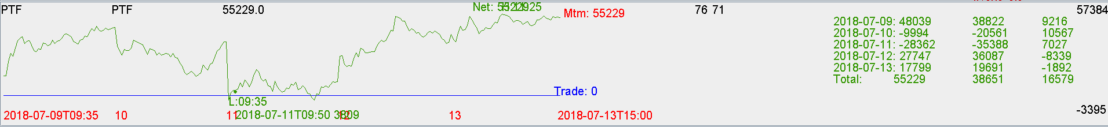

Futures:

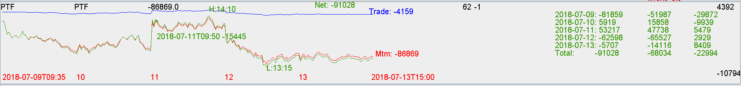

Overall: down 35k.

7.15

Why trading this week didn’t work

1. Selling all the way until hits lower limit on Monday ( should sell until delta limit)
2. Then was inflexible, couldn’t buy, was stuck with short 1 mm delta.
3. Delta check was precluding even the buying
4. There should be trading at 2 day extreme percentile.